SOC 411 LAB ASSIGNMENT #4

- Identify which is a Type I and Type II error (4 points):

a. In the population, there is no difference between men and women in the

number of hours they have watched The Voice. However, in a random sample,

you find a significant gender difference in hours watched of The Voice.
Type I error: Assuming that there is a gender difference in hours watched of The Voice while no difference exists in the population.

b. In the population, tap dancers can stand for longer periods of time than

members of “The International Couch Potatoes Club.” However, in a random

sample of 100 tap dancers and 100 members of the Couch Potatoes Club, you

find no significant difference in mean standing time between these groups.

Type II error: Missing a significant difference in mean standing time between tap dancers and members of the Couch Potatoes Club when there is a difference in the population.

c. In the population, men have higher levels of alcohol abuse than women.

However, in a random sample, you find no significant difference between men

and women in levels of alcohol abuse.
Type II error: Missing a significant difference in levels of alcohol abuse between men and women when there is a difference in the population.

d. In the population, rock guitarists and classical guitarists are equally

competent at identifying musical notes by ear. However, in a random sample of

100 rock guitarists and 100 classical guitarists, you find that the mean number of

notes accurately identified by rock guitarists is significantly higher than the

mean number of notes identified by classical guitarists.
Type I error: Assuming that classical guitarists and rock guitarists accurately identify notes differently when there is no actual difference between them.

- Next, we will look at the relationship between two nominal/ordinal variables of your choosing from the Alberta Survey dataset. Recode each variable so that there are only two valid response categories (if necessary). Be sure to exclude any missing data. Run a frequency of each variable and create a HA and H0 (your HA can be directional (or not) if you wish). Paste your syntax and output. (3 points)

FREQUENCIES VARIABLES strata.
RECODE strata (1=0) (2=0) (3=1)into Area.
MISSING VALUES area.
VALUE LABELS Area 0 'Metro Edmonton/Metro Calgary' 1 ‘Other Alberta’.
VARIABLE LABELS Area 'Area of the province'.
FREQUENCIES VARIABLES strata Area.

Original Variable:
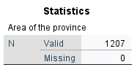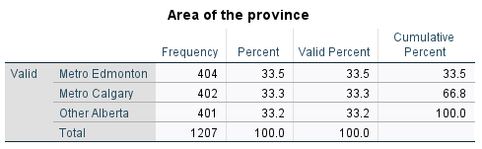

The Recoded Variable:
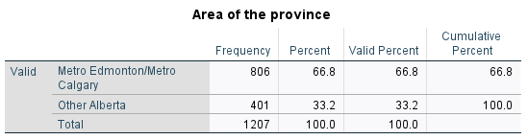

FREQUENCIES VARIABLES sex.
RECODE sex (1=0) (2=1) into sexrecoded.
VALUE LABELS sexrecoded 0 'Male' 1 'Female'.
VARIABLE LABELS sexrecoded 'Sex of Respondent'.
FREQUENCIES VARIABLES sex sexrecoded.

Original Variable:
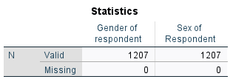
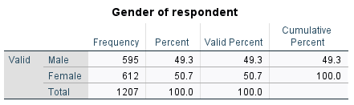

The recoded variable:
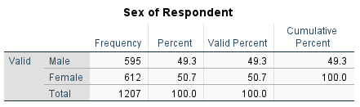

H0: The sex of respondent in Metro Edmonton and Metro Calgary is no different from other Alberta.
Ha: The sex of respondent in Metro Edmonton and Metro Calgary is different from other Alberta.

- Now run a crosstab of the two variables from Question #3 and interpret your findings. Be sure that your crosstab is properly formatted to examine your hypotheses. Paste your syntax and output. (4 points)

Crosstabs tables = sexrecoded by Area
/cells=column count
/statistics = chisq phi.
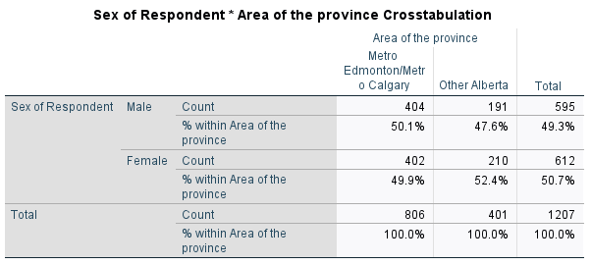

From this crosstab we see that 50.1% of males in Metro Edmonton/ Metro Calgary, as compared to 47.1% of males who live in other Alberta.
So far, this supports my research hypothesis, as a higher proportion of males are living
in Metro Edmonton’ Metro Calgary as compared to those who live in Other Alberta.
H0 is supported and Ha is rejected because the proportion of males and females in different regions is not much different.

- In order to test if any difference you have found in your crosstab is statistically significant, rerun your crosstab and apply the chi square test. Use the Phi test to determine the strength of the relationship between your two variables. Paste your syntax and output and interpret your findings. (2 points) (please note a chi square table is pasted below)
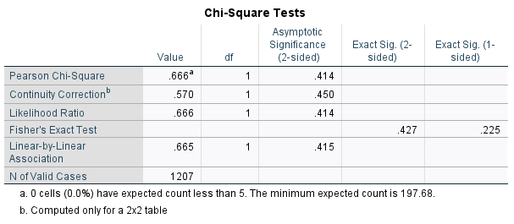
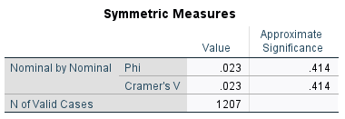
The chi-square value/statistic obtained is 0.666, well less than the critical value of 3.841
for a 2x2 table. Therefore, we can reject the null hypothesis of no relationship between
area of province and sex of respondent. Here, the value of Phi is at .023 so the relationship is weak. We conclude that the relationship between area of province and sex of respondent is significant but weak.

- Repeat steps 2-4 above but replace one of your variables with a variable with 3-5 valid response categories and use Craver’s V to assess the strength of the relationship. Paste your syntax and output and interpret your findings. (7 points) (please note a chi square table is pasted below)

We will be testing the relationship between h4 (best way for the government to reduce alcohol problems) and sexrecoded (Sex of Respondent). First, we must state our hypotheses. I already ran a frequency for sexrecoded above, so now I am just running a frequency table for h4. My hypotheses are also stated below:

FREQUENCIES VARIABLES h4.


Crosstabs tables = sexrecoded by h4
/cells=column count
/statistics = chisq phi.
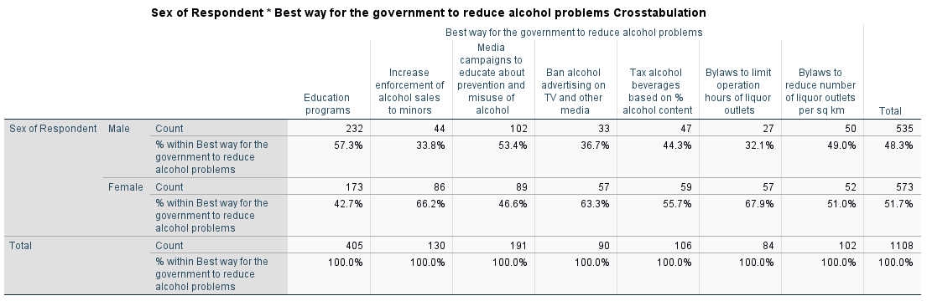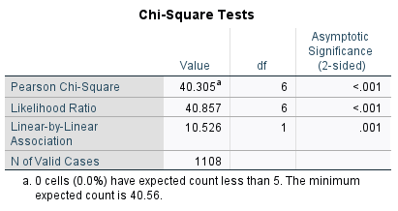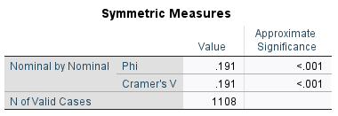
H 0 : The sex of the respondent does not vary by best way for the government to reduce alcohol problems.
H a : The sex of the respondent who has voted does differ by best way for the government to reduce alcohol problems.

- Select one of the relationships you have examined through a cross-tab so far in this lab and consider a third variable using the elaboration method. Paste your syntax and output and interpret your findings.

- Present a logical rationale for why the third variable (Z) may be antecedent or intervening (3 points)

- Rerun the crosstab and interpret the zero-order relationship (3 points)

- Run an elaborated cross-tab stratifying the table by Z and interpret the results to assess whether you have found replication, specification, explanation, suppression or distortion. (3 points)

Crosstabs tables = sexrecoded by H4 by Area
/cells=column count.

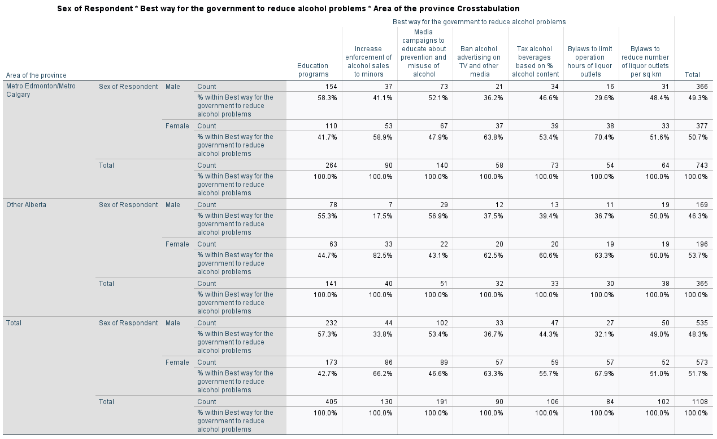

From this crosstab, we do not see a consistent trend related to sex of respondent and best way for the government to reduce alcohol but there does appear to be a relationship between our two variables.Those males were most likely to support education programs (at 57.3%), followed by males support media campaigns to educate about prevention and misuse of alcohol, males support bylaws to reduce number of liquor outlets per sq km (at 49.0%), males support tax alcohol beverages based on alcohol content (44.3%), males support ban alcohol advertising on TV and other media (36.7%), males support increase enforcement of alcohol sales to minors (33.8%), and males support bylaws to limit operation hours of liquor outlets (32.1%). Thus, we see differences across categories of the IV but no consistent positive or negative trend.

7. Using the Alberta Survey, Professor Lightman hypothesizes that there is a correlation between the number of credit cards you have (d9) and total household income (k12a), which we will treat as a continuous variable. Create a null hypothesis and an alternative hypothesis about the variables (your research hypothesis can be directional or non-directional). What is your IV and what is your DV? (3 points)

H0: There is no relationship between household income for the past year before taxes and the number of credit cards you have.
Ha (non- directional): There is a relationship between household income for the past year before taxes and the number of credit cards you have.
Ha (directional) – There is a positive relationship between household income for the past year before taxes and the number of credit cards you have.

The IV is household income for the past year before taxes and the DV is the number of credit cards you have.

8. Produce a scatterplot of the variables from Question #7 and examine any trends within the data – do they visually meet the assumption of linearity? Does the relationship appear to be positive or negative? Paste your syntax and output below and briefly interpret the graph. (4 points).

correlations
/variables = d9 k12a
/statistics descriptives.
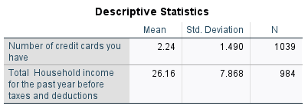
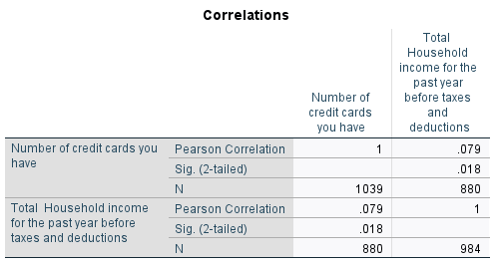

graph
/scatterplot= k12a with d9.

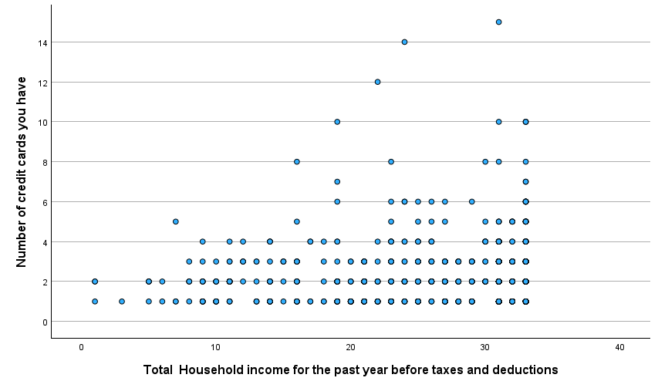
There is a positive relationship between household income for the past year before taxes and the number of credit cards you have. The household income is more, the number of credit cards you have more.

9. Using SPSS, calculate Pearson’s R and answer the following questions for the variables you have used in Questions #7 and #8. Paste your syntax and output below. (10 points)

a.What sample size was used for your two variables?
The sample size was 984 people for the variable on household income for the past year before taxes, and 1039 people for the variable on the number of credit cards you have.

b.What is the mean value of your two variables?
The mean household income for the past year before taxes is 26.16 and the mean number of
The credit card you have was 2.24.

c.Is the Pearson’s R value significant? Strong or weak? What does it mean? Does it support your hypothesis?
The Pearson’s R value is significant at the level of p < .1. Pearson's R value is positive and weak at 0.079. This means that there is a significant positive and weak association between household income for the past year before taxes and the number of credit cards you have- people with household income for the past year before taxes are associated with HIGHER
number of credit cards on average. This does support my analysis of the
scatterplot and the directional hypothesis I made.
d.How much does knowing a person’s income reduce error in predicting the number of credit cards?
R2 = 0.006 (0.079*0.079). This means that the error in predicting number of
Friends are reduced by 0.6% if we know how much a person’s income is.

e.Properly interpret the value of using the standard deviation.
SD. The standard deviation of person’s income is 7.868 and
The number of friends is 1.490. Using r we can state that a one SD increase in
Person’s income is associated with a 0.079 SD increase in
number of credit cards. In numbers, a 7.868 unit increase in person’s income is associated with a 0.118 (1.490 * 0.079) increase in the number of credit cards.

10. Rerun the analysis above in Q9 to calculate and interpret Spearman’s Rho in SPSS. Paste your syntax and output below. (4 points)

Nonpar corr
/Variables =k12a d9
/print = spearman.
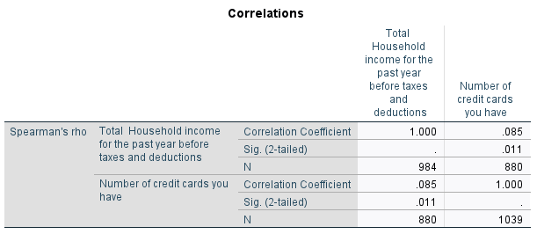
SPSS finds that the rank-order Spearman’s rho correlation between the two variables is 0.085. We therefore find a weak positive correlation between a person's income and number of credit cards. Knowing the rank on person’s income reduces the error of predicting the number of credit cards by 0.7% (0.085 * 0.085). However, we can also see that the correlation is NOT statistically significant at 0.011 level with p>.05.

